**Project Description** (Updated)

I will make a Chinese card game called Guan Dan. It is a 4-player card game and the rules are complicated. More information on this game can be found on this website: <https://www.pagat.com/climbing/guan_dan.html>.

The project includes an AI mode (offline mode).

**Competitive Analysis** (No change)

There are a few online Guan Dan programs that allow multiplayer connection, but I have not found one with AI mode, because of the extremely complicated techniques of playing. In my project, I will try to do develop a game AI that at least does not make the player feel boring.

**Structural Plan** (Updated)

The project will include the file “CardGame.py”, which includes basic classes like Card, Deck, Player, Game, etc. Then there is a file “offlineMode.py”, which uses Pygame to run the offline mode of the game. Algorithms for the AI will also be written in the “CardGame.py” file, as a method of the “Player” class.

**Algorithmic Plan** (No change)

The game AI is apparently the most complex part of the project. My current plan is to first organize the cards into different playable hands, and then calculate the weighted value of each hand (how much we want to get rid of a hand). The basic logic is to attack other players with minimum resources.

**Timeline Plan** (Updated)

Apr 16: finish the basic process of the game without AI

Apr 20: finish a functional AI and decorate the UI a bit

Apr 23: improve the AI and make the offline mode playable

Apr 29: continue to improve the AI and add features like save settings

**Version Control Plan** (Updated)

The code will be backed up in Google Drive.

The versions are named after the date of their last update.

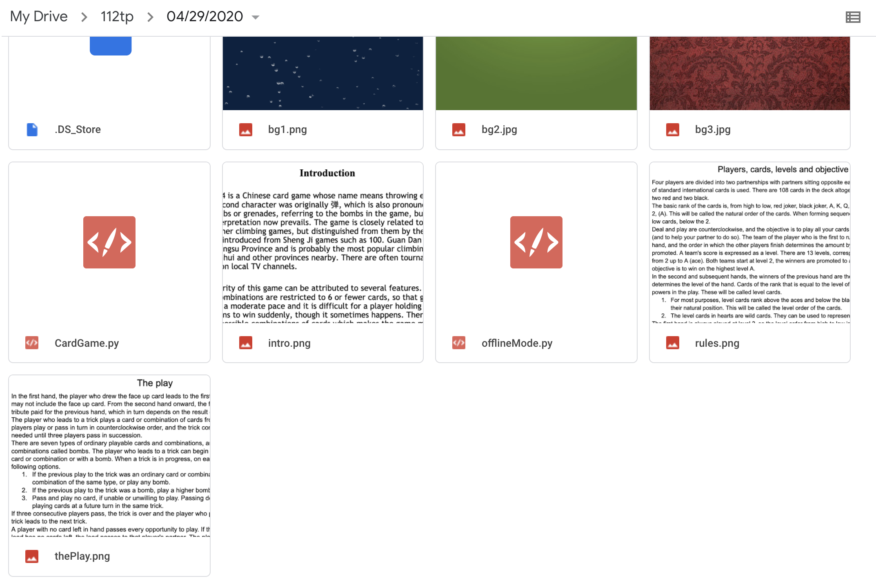

**Module List** (Updated)

* Pygame